AM2000-Asia-China-Jade-Bronze-Warring States-450-221 BCE

Bronze Jade-Mosaic Mirror镶嵌玉琉璃锺

Fuluoyuanjin Village傅洛院金 村

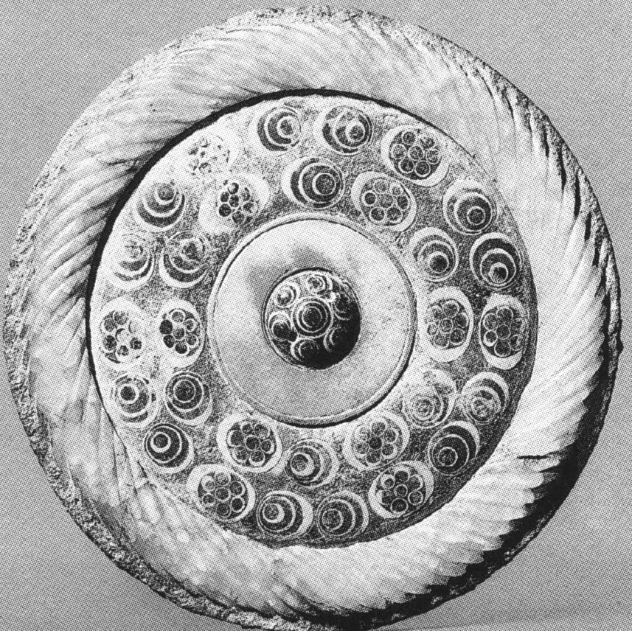

The inlaid jade Liuli Chung  
Saddle round  
Helpless twelve • two centimeters Fu Luo Institute Golden Village unearthed  
Blue the Liuli button 'with a white ferrule grabbing a girl, Block jade flaw. Outer ferrule relative wide blue colored glaze embedded six white flower-shaped public opinion. Mirror marry the case of of Xuxu Syria jade flaw. This mirror work exposing special 'colors the color target Cave' is rather a precious

Asia-China-Jade-Bronze-Warring States-450-221 BCE

Case No.:

Accession Number:

Formal Label: Asia-China-Jade-Bronze-Warring States-450-221 BCE

**Display Description:**

This jade and swirled glass bronze mirror offers the most ancient conception of the cloud motif in a blown glass medium encased in jade which dates to the Warring States Period, 450-221 BCE. Fuluoyuanjin Village傅洛院金 村 where this mirror was found was in the orbit of the ancient non-Chinese Bronze Age culture of Sānxīngduī (三星 = “three stars mound”), known in Chinese as the Shu culture , a unique civilization in this region before the Qin conquest. (Liang et al. 2001:271). This Bronze Age culture of Sānxīngduī has been divided into two sub periods (1730-1400 BCE and 1400-1200 BCE.

LC Classification: DS 793

Date or Time Horizon: Warring States-450-221 BCE

**Geographical Area:** Fuluoyuanjin Village傅洛院金 村, Chengdu Area, Sichuan

Map:

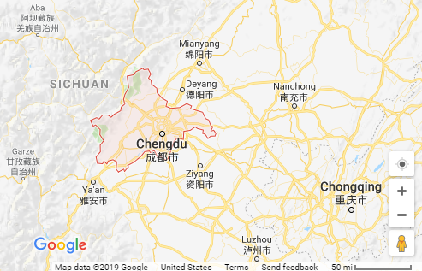

GPS Coordinates: Chengdu ([Tianfu Square](https://zh.wikipedia.org/wiki/天府广场)): [30°39′25″N104°03′58″E](https://tools.wmflabs.org/geohack/geohack.php?pagename=Chengdu&params=30.657_N_104.066_E_type:adm2nd_region:CN-51_source:Gaode)

Cultural Affiliation:

Medium: Bronze Jade-Mosaic

**Dimensions**:   
**Weight:**

**Provenance**:

**Condition:**

**Discussion:**

**References:**

Liang Deng; et al. (2001). [*History of China*](https://books.google.com/books?id=lFRVNTo77vEC). [*China Intercontinental Press*](https://zh.wikipedia.org/wiki/五洲传播出版社). p. 171.

Sage, Steven F. (1992). [*Ancient Sichuan and the unification of China*](http://trove.nla.gov.au/work/20359334?selectedversion=NBD8161066). Albany: State University of New York Press. p. 16.